## Problem 3 – Transformations

Create a Web form (HTML5 + CSS3 + images) that looks and behaves like the screenshots below:

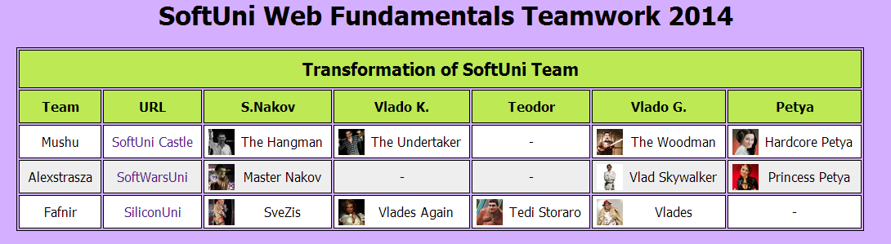

Even Row

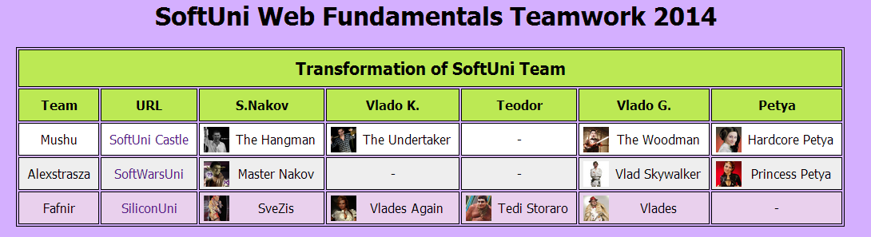

Hovered Row

* The green bullets are not part of your table, so please skip them.

### Input

You are given the above screenshots + the icons.

### Output

The output should be valid HTML5 + CSS3 + images that implement the above Web form.

### Constraints

* Fonts: Tahoma.
* Table width: 1150px (fixed size).
* Table background: fills the entire page.
* The site should open correctly in Chrome 35.
* Responsive design is not required.
* Pixel-perfect implementation is not required.